**[Track 1: Prophet of desolation]**

[A shadow of a man in the middle who commands to march. From the far city of Persepolis who heard of the gruesome attacks by Zarathustra who for unknown reasons turned dark and started attacking humans, followed by hordes of demons he is heading to the capital “Persepolis”.]

Far in the distant shadows

Faint dismal sound of crying

And furious we did scream

“The mortals will all die”

Ascend the glorious warriors

From forty legions of hell

And flying winged daevas

Casting their darkest spells of fire!

The stench of sulfur is burning my eyes.

As rivers of blood beneath me steam.

For I am the prophet, whom the mortals always seen

as a feeble weakling, unworthy to reign

But tonight the moon shines from my blade.

My mark of death will never fade, forever!

Hordes of shadows, dancing upon my eyes

I bring desolation, with all the horror from beyond

“As the dark forces storm the gates of “Persepolis”, burning and devouring every human they see. The prophet walked covered in blood, and to the imperial palace he marched”

Not faraway in the distance.

I hear the cries of Darius

Fallen king of dying mites.

Behold the wrath of the immortals.

My reign will be a thousand years

Of blood spells,and winds of fire.

Deep in the heart of shadows

Long wailing sounds of crying

Victorious we did scream

The mortals will all die,in fire

“Darius and his army appear by the gates as they ambush the city . The prophet mounts “Aeshma” and to the battle he rides.”

Distance, I hear the howlings from the distance.

As Ahriman charges to our side

For we, the prophets of desolations

Our blaze of victory burning the skies

Summon the wolves to feast!

[The day Zarathutra turned dark] Lyrics

Dark came the skies

As the Daevas arrived

Under black rain

The earth got stained

With Mazda’s blood

Mixed with mud.

Descend in hate

Ahriman the great

As the battle is won.

And the prophet arrived.

To watch the sign of Ahriman’s victory.

Watch the signs.

To submit to Ahriman’s will.

And obey.

[Tower of silence]

[Right before the attack on persepolis. In a small house on the outskirts. A child slept in his mother's arms in bed. As the window was open and the moonlight covered all the room.

Shades began to appear from afar. And bigger and bigger they got, a loud thud his the house as the child opened his eyes, and said:]

When the shadows from the stars fell.

Oh terror imbued our hearts.

Mother, your blood is spilt with mine.

Your dying breath smelt like iron.

Oh dreams,of land and beauty.

Oh woes, of reality.. and death.

Silent but mad were the laughs.

The prophet and the deaves arrived.

We float into the night.

To the Tower of silence.

We bleed through the night

Tower of death.

We bleed with the night.

Tears fell off the stars

They stare and they weep.

I lay awake, in the dark.

Mother is asleep, in the dark.

Till we unite in the sky.

Character design:

Child should look pretty poor/thin and very innocent looking. Doesn’t need a detailed face as his face could be as the video i shared with you. He wears something similar to this (without the hat)

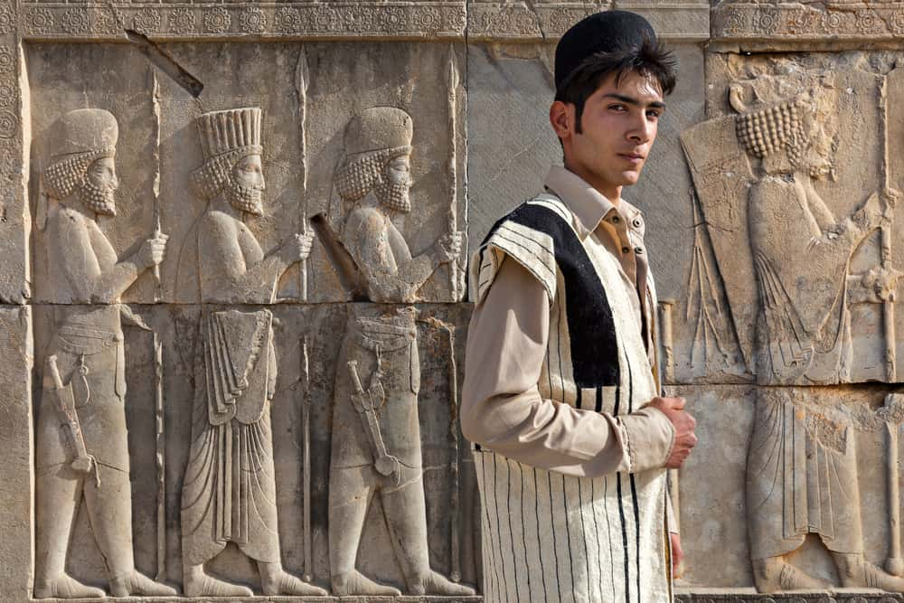

The mother is similar to the design below but still dark looking with a thin veil in her face.

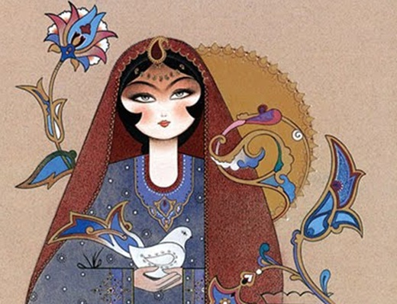

Intro for the first minute :

View of The moon and the stars and going down into a poor house where the view moves to inside where a boy (around 5 years old) Sleeping next to his mother on the floor, the view from above for the child and his mother. They are sleeping next to each other and near there is a window.. Their house is poor but small wooden toys are around and it’s comfy looking. The child is cozying next to his mom. Different shot of the mother holding her hand around the child.

Shadows appear to be flying across the window causing shade to cover the mother and the child. It appears and reappears until it covers the whole room and it wakes up the child who goes to the windows and the view from the window to dark monsters coming with the stars in the background and they are covering the sky then they fly into the window. View as from the POV of the child staring from a window and looking at watching the monsters filling the sky, I want them to be like dark shades with evil eyes with not so much details. They storm into the window causing total darkness.

As This scene playing with the guitar intro and the lyrics start: When the shadows from the stars fell, oh terror in our hearts.

Minute 2:

On the floor with his mother both covered in blood and he approach her crawling and speaks to he (there is no roof any more and everything scattered around):

Mother, your blood is spilt with mine.

Your dying breath smelt like iron.

Flashback to their time happy around the house and close shot to the mother smiling and in the same close it changes to the face of the mother covered in blood and dead as the part goes:

Oh dreams,of land and beauty.

Oh woes, of reality.. and death.

The mass shadows outside the city rumbles start laughing in evil way as they cover the city, in heart of the shadow a shape resembles a prophet hat (any symbol for zatahustra but dark looking)

Silent but mad were the laughs.

The prophet and the deaves arrived.

Out of the shadows a clawed hand gives a signal to rise to the dead bodies of the mother and child to rise. So it starts floating from the floor flying into the air.

Minute 3:

We float into the night

The the view is to the child and the mother body floating towards a far away tower of silence, its night and the bodies floating and bleeding drops of blood

To the Tower of silence.

We bleed through the night

Tower of death.

We bleed with the night.

For this minute different angles to their bodies flying and other bodies are joining them too from around the city and the view from above to hundreds of bodies flying into the sky and moon and stars in the background.

Minute 4:

They start getting dropped like rain over the tower of silence in different directions. The child drops and around him bodies drop and parts of bodies.

Bodies keep falling it it fills the screen and view changes to the full picture of the stars and the tower of silence and the stars are weeping in the background and its raining,

Tears fell off the stars

They stare and they weep.

Picture changes to black, then two eyes of the child open , then the picture turns into gray and star to be more clear of them sleeping in the same positions like the start but away from each other, with the child hand stretching to her direction and the mother hand stretching far away in his direction, the tower of silence have a circle in the middle so they are in the opposite sides of the circle.

I lay awake, in the dark.

Mother is asleep, in the dark.

Till we unite in the sky.

Minute 5:

View from the POV of the child where he sees the rain, and his mother body far away, looking to the dead bodies around him, then looking into the sky and everything fades with the moon and the star again.

[Elegie]

[As the dawn arrived over the tower of silence on the sight of the burnt city of persepolis. A wind breath carried a message that went through the mutilated body of the mother and to the face of the dead child. As he heard:]

Oh my sweet boy,

Through all tears,

Through all the fears,

Together with the stars we belong.

Far away to the beyond of beyond

We fly hand in hand

Together in the stars we belong.

Far away to the beyond of beyond

We fly hand in hand

Together with the stars we belong.

Through all the tears, all the fears and all the pain.

We live again. With the stars.

[On Aeshma’s wings Lyrics]

[After the prophet Zarathustra left the ruins of Persepolis, he mounted Aeshma, the demon of wrath and prince of the underworld. And as they fly through the night the prophet stroke Aeshma’s wings and spoke:]

The Night and the Stars aligned.

For a journey to a world behind.

Unholy curtains of the night.

Demon of wrath.

Keeper of hate

Bringer of agony

Evil incarnate

Phantasmagoria of a dance of the shades.

Phantasmagoria of a march of the blades.

We descend into the fields

Of darkness and the horror it wields

Lord Aheshma opens for me the gates!

Phantasmagoria of a dance of the shades.

Phantasmagoria of a night of the blades.

[In their Darkest aquarium]

Behold the cold embrace

Of icy gleams of death

I hear the moans, i hear the shrieks of hate

Of dark creatures, shrouded in black, their hearts.

Engulfed in terror, entwined with agony, my heart.

There was an infant, in dark aquarium,

I watch her drown, In silent tears.

In a breathless gaze, she stared into my eyes.

Her body glazed, with the cold fade of death.

The deaves moaned louder with pleasure

As her forever cradle is their darkest aquarium

A hallowed ethereal angel in the dark

Her tears are eternal. Her tears are stark

A hallowed ethereal angel in the dark

And now she only knows pain…

[Child singing]

Forever and ever i sleep

In dark waters i weep

I yearn for life, i yearn for death

Yet i float in a dark aquarium

[As she drowns]

No lyrics -Track describes a little girl dead in an aquarium dreaming about her past.

[Upon the mortal blight Lyrics]

Carry your spears, messengers of fear.

Under a black moon.

As night shade covers us as we strewn.

Vent down your wrath, pour down your hate.

Destroy their pyres.

Burn down their gates.

Follow my rage, follow my blood marks.

It all ends here, demons of darkness

Vent down your madness, painted in blackness.

Fly and crown me prince of the murders.

Nocturnal call.

Demised souls.

We watch them bleed.

We bathe in the blood of the mortals.

You can run, but you cannot hide.

You worm in human’s skin.

I smell your breath, I hear your cries.

Begging for thy morbid lives.

As the moon turned to black.

Images turned into a dream.

As we march into a slaughter.

In the realm of nightmares.

Servants of Ahriman.

Bringers of doom.

Enfold Mazda’s creation in gloom.

Predators of fire, serpent of hell.

Cast thy name upon darkest spells.

By leaders of the underworld.

I take my golden throne.

To rule my kingdom of..

Of Darkness and sin.

To redeem the mortals' lives.

Ov mysteries of forgotten sins.

Unveil the falsity of their idols.

As idols got burnt, again.

Cult of fire..Cult of death

Cult of fire..behest..

Destroy their pyres.

Burn down their gates

Prancing through

The ruins of fate.

Unholy deavas .

Ascend from the flames

To burn all the mortal blight.

Nocturnal call.

Demised souls.

We watch them bleed.

We bathe in the blood of the mortals

By leaders of the underworld.

I take my golden throne.

To redeem the mortals' lives.

Ov mysteries of forgotten sins

Unveil the falsity of their idols

As idols got burnt, again.

[The prophet stood away watching the flames painting the skies. As the mortals burnt with their idols and their cities turned to ashes]

[Outuro]

[Last scene, after Zarahustra completed his vengeance, he heads to the shore, all the deaves disappeared and he he was completely alone with this thoughts]

As the last curtain of the night

Fell down beyond my weary eyes

Alone i wander across the shore

For this life, or what I thought it has been.

Alone, I have always been alone.

I slit my wrist and bleed.

O’ darkness i am coming. O’ darkness I am fading. O’ darkness i am here.